LeafInjuryR: an auditable R package to quantify foliar symptom severity and predict expert visual assessments
Wilhan Valasco dos Santos¹
¹ [Institution, city, state, country – to be completed]. E-mail: wilhanvalasco@hotmail.com. ORCID: [to be completed].
ABSTRACT
Visual estimation of foliar disease severity is subjective and varies among raters, even when standard area diagrams are used. This work presents LeafInjuryR, an open-source R package that quantifies foliar symptoms in photographs through classical image processing, with leaf segmentation, tissue classification restricted to the leaf mask, quality control, complete parameter records and a local Shiny interface. The package was evaluated on 48 soybean leaflets with target spot (Corynespora cassiicola) whose severity was estimated by four agronomists aided by a standard area diagram. The range among raters reached 58 percentage points on a single leaflet and, depending on the threshold adopted, 12.5% to 25.0% of the leaflets would be classified inconsistently regarding the need for intervention. LeafInjuryR severity was highly precise relative to observed severity, defined as the rater median (r = 0.90) but showed moderate raw agreement (Lin's concordance correlation coefficient, CCC = 0.70) because it overestimated severities above 10%. The relationship between methods was best described by a power model (y = 2.26x^{0.637}; R² = 0.83). In cross-validation, the observed severity predicted from LeafInjuryR reached a CCC of 0.89 and a mean absolute error of 2.77 percentage points, similar to three raters compared with the consensus of the others (CCC of 0.90 to 0.93) and better than the fourth rater (0.63). LeafInjuryR is a precise and reproducible predictor of observed severity once calibrated; pixel-level validation and evaluation in other pathosystems remain necessary.
Keywords: phytopathometry; image analysis; Glycine max; Corynespora cassiicola; inter-rater agreement.

1 INTRODUCTION
Severity, defined as the proportion of plant-organ area showing symptoms, is the most widely used variable for assessing foliar diseases in cultivar-resistance trials, fungicide-efficacy studies and epidemiology (Madden, Hughes & van den Bosch, 2007; Bock et al., 2010). Because it relies on human perception, visual severity estimation is prone to overestimation at low levels, preference for rounded values, systematic differences among raters and low repeatability (Nutter Jr. et al., 1993; Bock et al., 2010). Standard area diagrams reduce these errors and are widely adopted (Horsfall & Barratt, 1945; James, 1971; Del Ponte et al., 2017), including for phytosanitary complexes of soybean (Peixoto, 2023), but they do not eliminate subjectivity, which remains relevant when several raters contribute to the same trial (Bock et al., 2020; Bock, Chiang & Del Ponte, 2022).
In soybean, target spot, caused by Corynespora cassiicola, produces necrotic lesions surrounded by a chlorotic halo that may coalesce and cause extensive yellowing of the leaflet, so that the boundary between symptomatic and healthy tissue is often diffuse. Under these conditions, what should be counted as diseased area varies among raters and directly affects the estimated severity and the decisions derived from it.
Digital image analysis allows severity to be measured by counting pixels classified according to explicit criteria (Barbedo, 2013, 2014; Mutka & Bart, 2015). Programs such as Assess (Lamari, 2008), ImageJ/Fiji (Schneider, Rasband & Eliceiri, 2012; Schindelin et al., 2012), Leaf Doctor (Pethybridge & Nelson, 2015), PlantCV (Gehan et al., 2017) and the R package pliman (Olivoto, 2022; Olivoto, Andrade & Del Ponte, 2022) made this approach accessible, and deep-learning methods have reached high performance in disease detection (Mohanty, Hughes & Salathé, 2016; Barbedo, 2019), although they require large annotated datasets and offer little transparency about the decision criterion (Singh et al., 2018). Two problems, however, remain little explored. The first is technical: vegetation indices such as excess green (Woebbecke et al., 1995; Meyer & Neto, 2008) tend to exclude from the leaf precisely the necrotic tissue to be measured (Hamuda, Glavin & Jones, 2016). The second concerns reproducibility: interactively chosen thresholds are rarely recorded with the result, which prevents the analysis from being reconstructed (Sandve et al., 2013; Lobet, 2017).
Moreover, comparisons between image-based measurements and visual assessments are usually presented as tests of software accuracy, although the visual reference itself contains error. A more useful question for experimentation is how well an automated measurement predicts the visual assessment of experts and whether that prediction is comparable to the agreement among the raters themselves. The aim of this work was to present LeafInjuryR, an auditable R package for quantifying foliar symptoms, and to evaluate its ability to predict expert visual estimates of soybean target spot severity made with a standard area diagram, relative to the variability among those raters.

2 MATERIALS AND METHODS

2.1 Package implementation
LeafInjuryR was implemented in R (R Core Team, 2024) following the package-development practices of Wickham and Bryan (2023), with image processing by EBImage (Pau et al., 2010) and a graphical interface in shiny (Chang et al., 2024). The public interface comprises six functions (Table 1), and all processing is local. The workflow (Figure 1) explicitly separates leaf segmentation, tissue classification performed only on pixels of the leaf mask, and quantification. Each result records the versions of the package and dependencies, the date, the MD5 checksum of the file, the thresholds actually applied, removed components, manual corrections and the complete configuration, which allows the analysis to be reproduced.
Table 1 – Public functions of LeafInjuryR 0.2.0
Function | Purpose | Main outputs
crop_leaf() | Automatic (leaf box + margin) or manual cropping, without resampling | Cropped image and crop coordinates
segment_leaf() | Leaf segmentation, tissue classification and logged manual correction | Leaf mask, class map, thresholds and corrections
analyze_leaf() | Complete analysis of one image | Areas, severity, quality control and parameters
analyze_leaf_batch() | Batch analysis with standardised parameters | HTML, Excel and CSV reports, masks and overlays
validate_leaf() | Quality control and validation against reference masks | Warnings; IoU, Dice, sensitivity, specificity, precision and F1
run_leafinjury_app() | Local Shiny interface with four areas | Image, Segmentation, Analysis and Results
Source: the author (2026).
Figure 1 – Architecture and processing workflow of LeafInjuryR
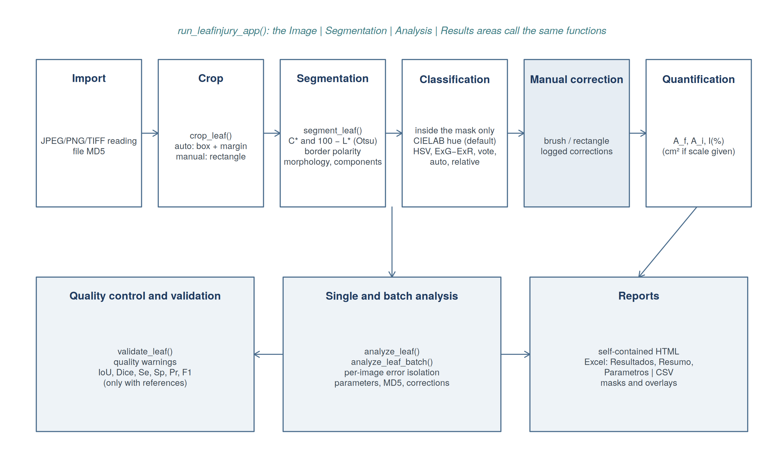
Source: the author (2026).
Colours are converted from sRGB to CIELAB under the D65 illuminant (Commission Internationale de l'Éclairage, 2004), and chroma and hue angle are derived (Equation 1). The leaf mask is obtained with Otsu thresholds (Otsu, 1979; Sezgin & Sankur, 2004), which maximise the between-class variance of each feature histogram (Equation 2), where ω₀ and ω₁ are the proportions of pixels below and above threshold t, μ₀ and μ₁ the corresponding means and η the separability. In the default method, chroma C*_{ab}, which distinguishes green and yellowish tissue from an achromatic background, and darkness 100 − L*, which captures dark low-chroma necrosis, are evaluated; the background side of each threshold is inferred from the image border, and the mask is the union of features with η ≥ 0.5 (Equation 3). This is followed by morphological opening, connected-component labelling (Rosenfeld & Pfaltz, 1966; Soille, 2003), removal of objects smaller than 0.1% of the image with every removal recorded, and filling of only those holes whose colour differs from the background.
$C_{ab}^{∗} = \sqrt{a^{∗2} + b^{∗2}}, h_{ab} = atan2\left(b^{∗}, a^{∗}\right)$ (1)
${σ_{B}}^{2}\left(t\right) = ω_{0}\left(t\right)ω_{1}\left(t\right){\left[μ_{0}\left(t\right) − μ_{1}\left(t\right)\right]}^{2}$ (2)
$M_{raw}\left(x, y\right) = 1\left[C_{ab}^{∗} > t_{C}\right] ∨ 1\left[100 − L^{∗} > t_{D}\right]$ (3)
Within the mask, a pixel is healthy when its hue lies between h_{min} = 100° and h_{max} = 200° and its chroma is at least 8 units (Equation 4); the remaining pixels are injured and, in multiclass mode, subdivided into chlorotic (hue between 85° and h_{min}), necrotic (hue below 85° or dark achromatic pixel) and other. Thresholds are fixed for all images so that the criterion does not vary with severity itself. The package also offers alternative rules, including one relative to the leaf's own dominant colour, intended for naturally pigmented leaves. Leaf area, injured area and severity are given by Equations 5 to 7, where M_{f} and M_{i} are the leaf and injury masks; areas in cm² are computed only when a scale is provided. Segmentation can be corrected with a brush or rectangle, and corrections are recorded in the result. Quality control issues heuristic warnings (e.g., heterogeneous background illumination) that never alter results, and batch analysis generates HTML, Excel and CSV reports from the same table.
$S\left(x, y\right) = 1 ⇔ h_{min} ≤ h_{ab} ≤ h_{max} ∧ C_{ab}^{∗} ≥ C_{min}$ (4)
$A_{f} = \sum_{x=1}^{W}{\sum_{y=1}^{H}{M_{f}\left(x, y\right)}}$ (5)
$A_{i} = \sum_{x=1}^{W}{\sum_{y=1}^{H}{M_{i}\left(x, y\right)}}$ (6)
$I\left(\%\right) = \frac{A_{i}}{A_{f}} × 100$ (7)

2.2 Images and visual assessment
Forty-eight photographs of leaflets of soybean (Glycine max (L.) Merrill) plants inoculated with Corynespora cassiicola, selected to represent a wide range of severity, were used ([cultivar, site, season, growth stage, inoculation method and camera to be completed]). The 1000 × 750-pixel images were acquired on a white background. Four agronomist researchers (R1 to R4) independently estimated the severity of each leaflet, as a percentage of symptomatic leaf area, aided by the standard area diagram for quantifying phytosanitary complexes in soybean proposed and validated by Peixoto (2023). This diagram depicts injured areas in black on the leaflet outline and comprises 12 severity levels (0, 0.5, 6, 11.5, 17, 22.5, 28, 33.5, 44.5, 50, 61 and 87% injured area), defined from severity measured with Assess on 110 images; in its validation with eight raters, use of the diagram raised the coefficients of determination between estimated and actual severity to 0.77–0.91 (Peixoto, 2023). The same images were analysed with LeafInjuryR 0.2.0 in its default configuration, with automatic cropping and without any prior tuning of parameters to this set. No pixel-level reference masks were produced, so the evaluation concerns estimated severity.
The median of the four raters' estimates for each leaflet was adopted as the reference and is hereafter called observed severity (%). Three raters showed mutual correlations of 0.91 to 0.93, whereas the fourth showed correlations of 0.71 to 0.75 and isolated extreme values; with four raters, the median equals the mean of the two central estimates and is less sensitive to individual discrepancies than the arithmetic mean (Bock et al., 2010).

2.3 Statistical analysis
Inter-rater variability was described by the range and coefficient of variation of the four estimates per leaflet and by absolute-agreement intraclass correlation coefficients for a single rater, ICC(A,1), and for the mean of four, ICC(A,4) (McGraw & Wong, 1996), with 95% confidence intervals from a bootstrap with 2,000 resamples. The sensitivity of LeafInjuryR severity to the available classification rules and to the threshold h_{min} (90° to 110° in 2° steps) was evaluated on the 48 images, keeping the same leaf mask within each image. To express the effect of subjectivity on decisions, the proportion of leaflets for which at least one rater placed severity below a threshold and another above it was computed for thresholds of 5%, 10%, 15%, 20% and 25% severity.
The ability of LeafInjuryR to predict visual assessment was analysed by regression, with observed severity as the response (y) and LeafInjuryR severity as the predictor (x). Linear and power models (Equation 8), and quadratic, logarithmic (y = β₀ + β₁ ln x) and asymptotic (y = α(1 − e^{−βx})) models were fitted by ordinary or nonlinear least squares. Models were compared by the corrected Akaike information criterion (AICc), the coefficient of determination and the leave-one-out cross-validated root mean squared error (Equation 9), where ŷ_{(−k)} is the prediction for leaflet k from the model fitted without it. 95% confidence bands were obtained analytically for linear models and by case bootstrap (2,000 resamples) for nonlinear models.
$y = β_{0} + β_{1}x + ε, y = αx^{β} + ε$ (8)
${RMSE}_{cv} = \sqrt{\frac{1}{n}\sum_{k=1}^{n}{{\left(y_{k} − ŷ_{(−k)}\right)}^{2}}}$ (9)
Agreement was assessed with Lin's concordance correlation coefficient (Equation 10), where s_{xy} is the covariance, s²_{x} and s²_{y} the variances and x̄ and ȳ the means, with a 95% confidence interval from the z transformation (Lin, 1989), and with the mean absolute error. Raw agreement between LeafInjuryR and observed severity and agreement between the cross-validated predictions of the best model and observed severity were computed. For comparison, each rater was compared with the median of the other three. Analyses were performed in R 4.3.3, with graphics from ggplot2 (Wickham, 2016), in a parameterised R Markdown document that reproduces every figure and table in Portuguese or English.
$ρ_{c} = \frac{2s_{xy}}{{s_{x}}^{2} + {s_{y}}^{2} + {\left(x̄ − ȳ\right)}^{2}}$ (10)

3 RESULTS AND DISCUSSION

3.1 Package performance
LeafInjuryR 0.2.0 passed R CMD check without errors, warnings or notes and 256 unit tests, which verify, among other properties, that pixels outside the leaf never enter tissue counts and that repeated analyses produce identical masks. On synthetic images with known ground truth, the leaf mask was recovered with an intersection over union of 0.9999, and the severity error ranged from +0.002 to −1.31 percentage points depending on the noise level.
Figure 2 illustrates the importance of leaf segmentation. In a leaflet with extensive marginal necrosis, the excess-green mask excluded 25.7% of the leaf area (agreement of 0.74 with the final mask), and the chroma-only mask omitted 5.8% of the area, concentrated in the necrotic margin. Because these pixels are mostly injured, their exclusion simultaneously reduces the numerator and the denominator of severity and leads to underestimation, which justifies the combination of chroma and darkness in the default method.
Figure 2 – Analysis steps on a soybean leaflet with target spot: (a) cropped image; (b) excess-green mask; (c) chroma-only mask; (d) final leaf mask; (e) tissue classes (green: healthy; yellow: chlorotic; red: necrotic; magenta: other); (f) overlay
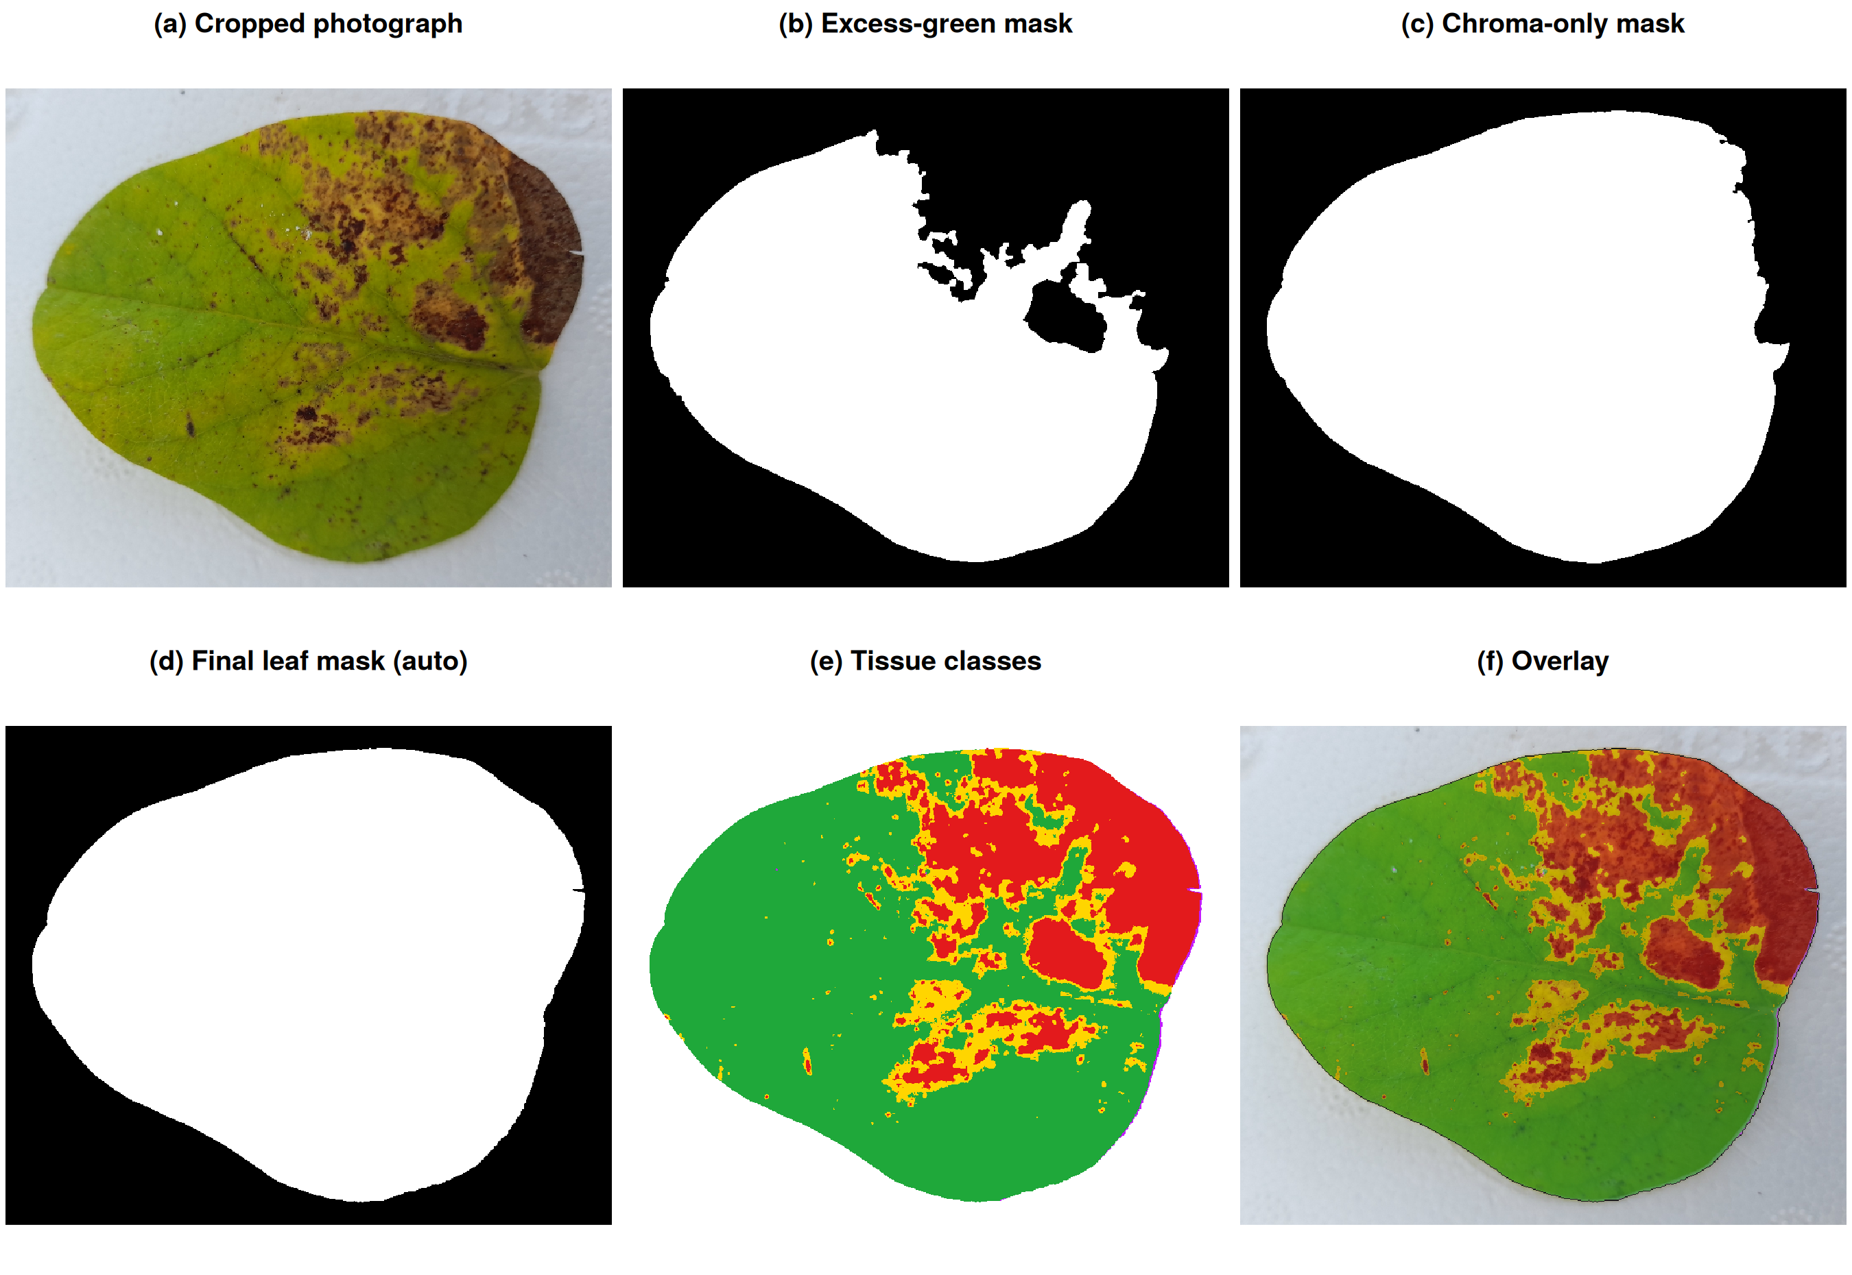
Source: the author (2026).
Tissue classification was the most sensitive step (Figure 4). Across the 48 images, keeping the same leaf mask, the lab, hsv and vote rules yielded median severities of 13.3% to 13.6%, whereas the exgr, auto and relative rules yielded medians of 8.4% to 9.6% (Figure 4a); within the same image, the difference between the highest and lowest estimate among rules had a median of 6.4 percentage points and reached 26.5 percentage points. Median severity increased from 6.9% to 13.3% and 75.0% as the healthy-tissue hue threshold went from 90° to 100° and 110° (Figure 4b), and near the default value each degree changed the estimate by a median of 1.2 percentage points. The slope increases above 102° because the threshold starts to cut through the mode of yellowish-green tissue; there is no natural valley in the hue histogram that objectively defines the boundary. The healthy–chlorotic threshold is therefore a methodological decision that must be kept constant and reported. The Shiny interface (Figure 3) allows each decision to be inspected visually before the result is accepted.
Figure 3 – Analysis area of the LeafInjuryR Shiny interface (Portuguese locale), with indicators and a slider comparing the original and processed images
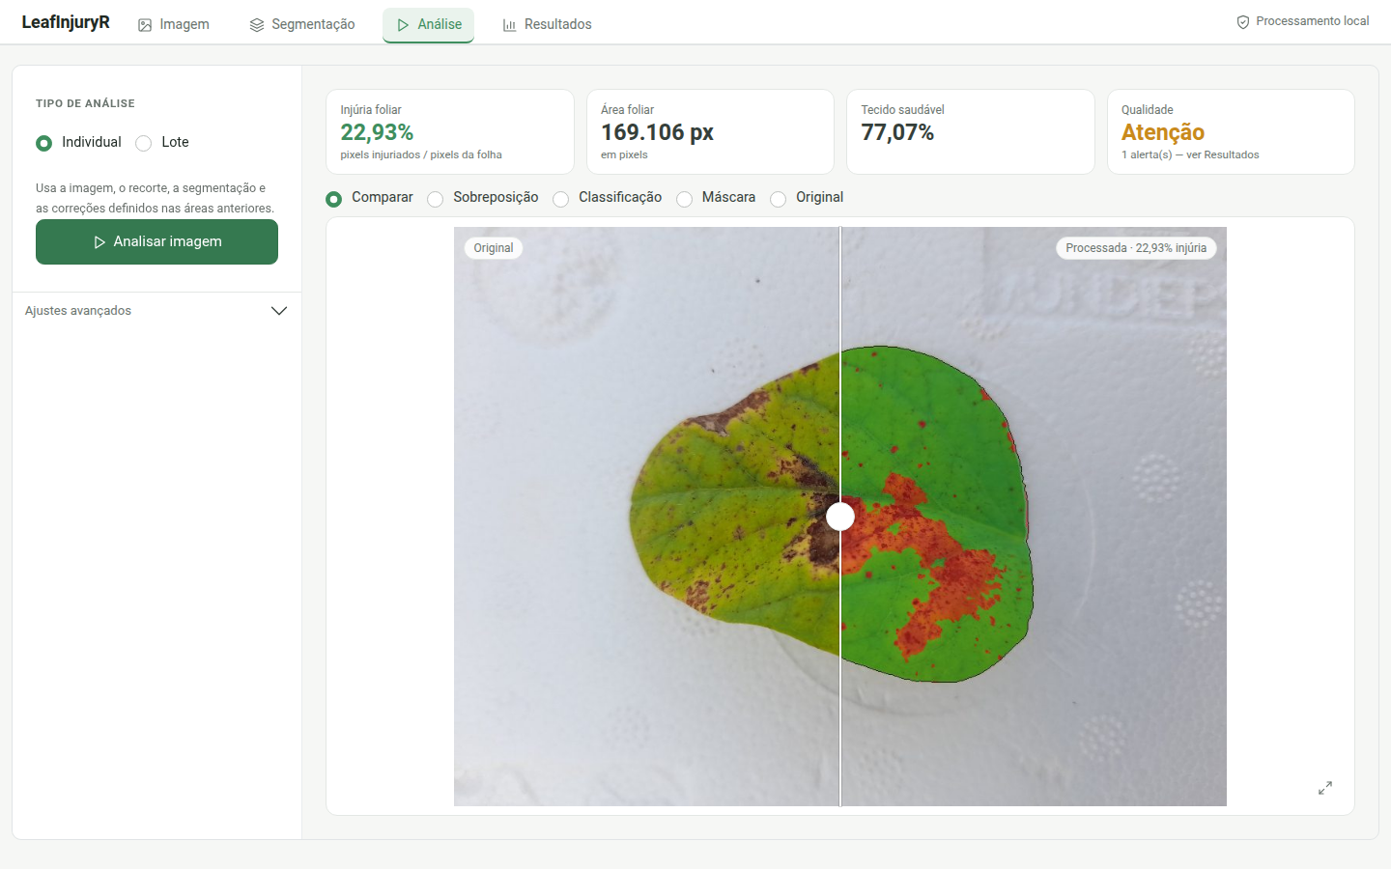
Source: the author (2026).
Figure 4 – Sensitivity of LeafInjuryR severity across the 48 images: (a) distribution of severity (violin, boxplot and points) by classification rule applied to the same leaf mask; (b) severity as a function of the healthy-tissue hue threshold, with median (line) and interquartile range (ribbon) of the 48 images; the dashed line marks the default value of 100°
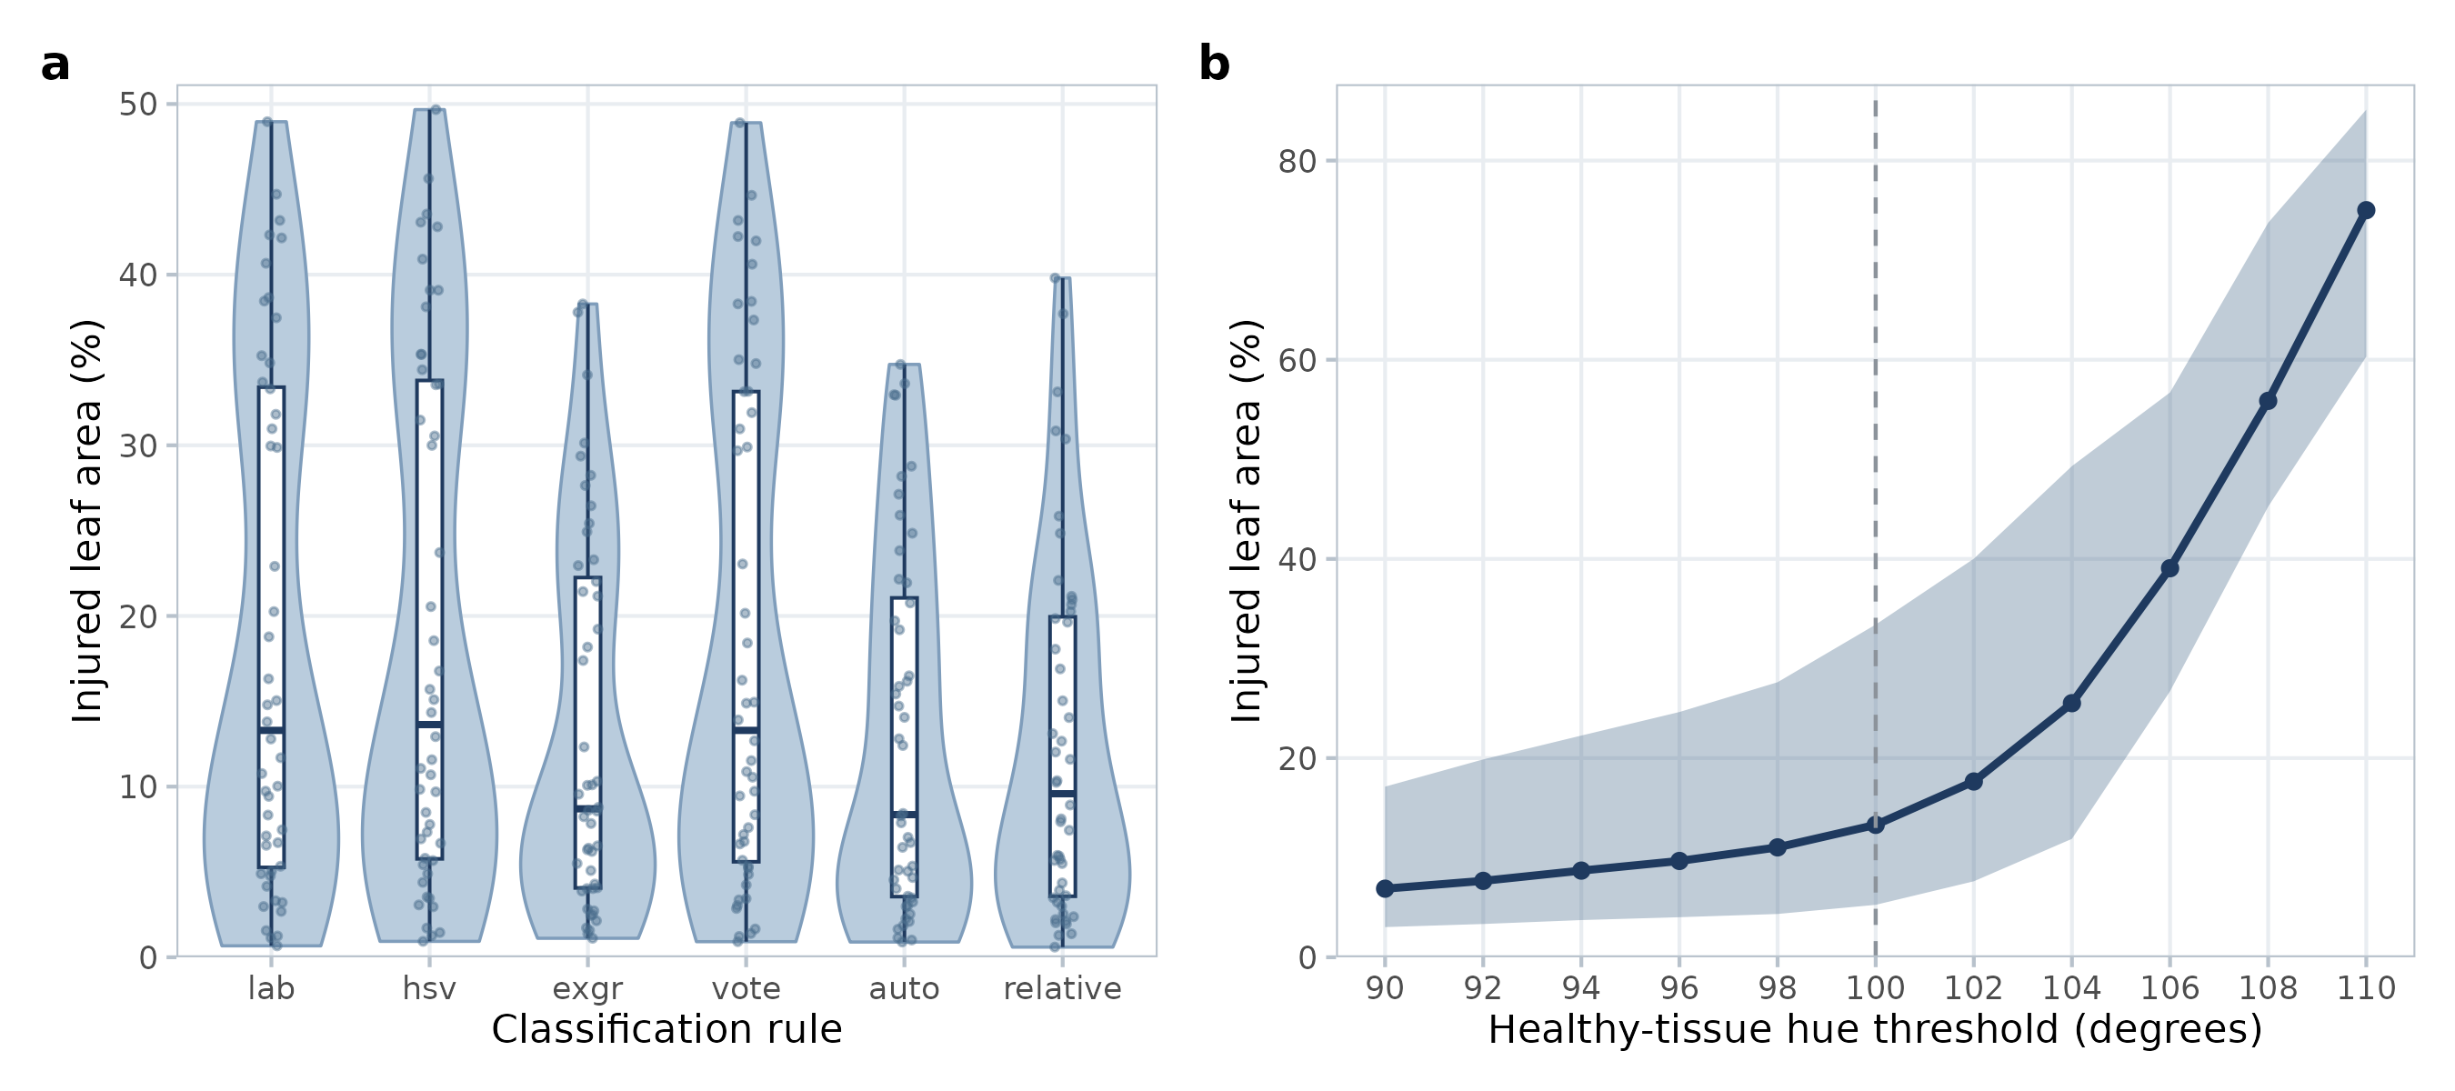
Source: the author (2026).

3.2 Subjectivity of visual assessment
Rater estimates diverged substantially (Figure 5a). The range among the four raters had a median of 4.5 percentage points, was 10 percentage points or more in 16.7% of the leaflets and reached 58.3 percentage points on one leaflet, rated 77% by one rater and between 18% and 24% by the others. The median coefficient of variation among raters was 21.9%. Reliability was moderate for a single rater, with ICC(A,1) of 0.73 (95% confidence interval: 0.53 to 0.90), and high for the mean of four, with ICC(A,4) of 0.91 (0.82 to 0.97). When each rater was compared with the median of the others, concordance coefficients ranged from 0.63 to 0.93 (Table 3).
The effect of this variability on decision-making was considerable (Figure 5b). For thresholds of 5% to 25% severity, such as those used to time fungicide applications or classify genotype reactions, 12.5% to 25.0% of the leaflets would be classified inconsistently, that is, at least one rater would place them below the threshold and another above it. This confirms, in a pathosystem with diffuse symptom boundaries, that standard area diagrams do not eliminate subjectivity (Bock et al., 2010; Bock, Chiang & Del Ponte, 2022) and that the choice of rater can change recommendations and the ranking of treatments. Automated measurement, in contrast, is deterministic: reanalysis of the 48 images reproduced the values with a maximum difference of 0.36 percentage points across computing environments and with identical results within the same environment.
Figure 5 – Inter-rater variability: (a) estimates of the four raters (points), range (bars) and observed severity (median, dash) per leaflet, with the axis limited to 45% (the arrow marks a value of 77%); (b) proportion of leaflets with a divergent decision among raters as a function of the severity threshold
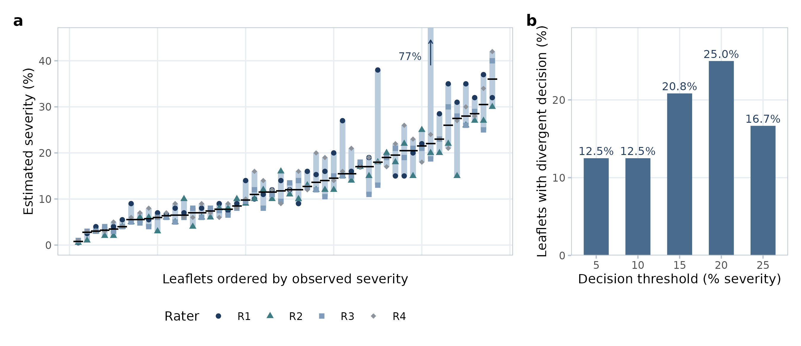
Source: the author (2026).

3.3 Prediction of visual assessment by LeafInjuryR
LeafInjuryR severity ranged from 0.70% to 48.8% (mean 18.7%) and observed severity from 0.75% to 36.0% (mean 13.4%). The relationship between them was monotonic and concave and is represented by the selected model (Figure 6a). The power model had the lowest AICc and the lowest cross-validated error (Table 2), although the linear, quadratic and asymptotic models performed similarly (ΔAICc of 2.6 to 2.9) and the logarithmic model was clearly inferior. The exponent of 0.637 indicates that observed severity increases less than proportionally to the software measurement: at low severities the methods practically coincide, and the divergence grows with severity. Without calibration, the mean bias of LeafInjuryR relative to observed severity was −0.38 percentage points for leaflets with observed severity up to 10%, +6.86 between 10% and 20% and +13.19 above 20%.
Table 2 – Models fitted to predict observed severity (y, rater median) from LeafInjuryR severity (x) on 48 soybean leaflets
Model | Fitted equation | ΔAICc | R² | RMSE | RMSE_{cv} | MAE_{cv} | CCC_{cv}
Power | y = 2.264 x^{0.637} | 0.00 | 0.826 | 3.49 | 3.71 | 2.77 | 0.892
Quadratic | y = 2.53 + 0.745x − 0.00533x² | 2.56 | 0.825 | 3.49 | 3.83 | 2.86 | 0.886
Linear | y = 3.94 + 0.507x | 2.80 | 0.815 | 3.59 | 3.81 | 2.92 | 0.886
Asymptotic | y = 29.85(1 − e^{−0.0389x}) | 2.90 | 0.815 | 3.60 | 3.84 | 2.90 | 0.891
Logarithmic | y = −2.71 + 6.54 ln x | 18.47 | 0.744 | 4.23 | 4.45 | 3.46 | 0.839
Source: the author (2026). ΔAICc: difference from the lowest AICc; RMSE: root mean squared error (percentage points); subscript cv: leave-one-out cross-validation; MAE: mean absolute error; CCC: Lin's concordance correlation coefficient.
The most plausible interpretation of the curvature involves the chlorotic halo characteristic of target spot. LeafInjuryR counts yellowish tissue with hue below 100° as injured, whereas the standard area diagram used depicts lesions in black, without degrees of yellowing (Peixoto, 2023), which tends to lead raters to weigh mainly necrosis. Image 3 in Figure 7 illustrates this situation: the leaflet shows extensive yellowing between lesions, and the software severity (38.5%) was twice the observed value (19.0%), whereas in leaflets with well-delimited lesions (Images 1 and 2) the values were close. In an exploratory analysis, comparing only the necrotic component with observed severity raised the raw concordance coefficient from 0.70 to 0.77, which is consistent with this hypothesis. Consistently, lowering the healthy-tissue hue threshold increased raw agreement with observed severity: the CCC, computed on the reanalysed images, rose from 0.700 at the default 100° (0.703 with the original values) to 0.858 at 96°, 0.892 at 94° and 0.905 at 92°, with mean bias close to zero (−0.21 percentage points) at 94°. This suggests that the implicit boundary adopted by the raters lies at yellower hues than that of LeafInjuryR, that is, part of the yellowish-green tissue counted by the software was not considered symptomatic. Because the threshold and the hypothesis were examined on the same data, these results are exploratory and must be confirmed on an independent set.
Figure 6 – (a) Relationship between LeafInjuryR severity and observed severity fitted with the power model, with 95% confidence band; (b) severity predicted by the power model in leave-one-out cross-validation versus observed severity, with 1:1 line (dashed) and linear regression with 95% confidence band
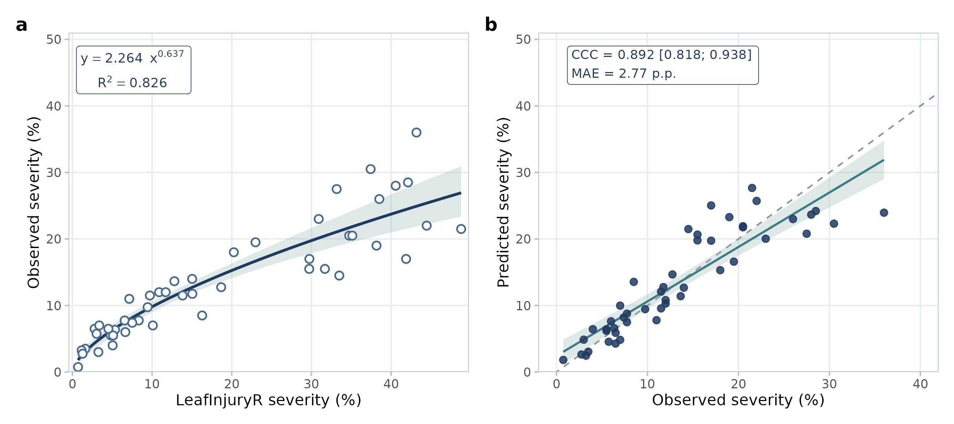
Source: the author (2026).
Raw agreement between LeafInjuryR and observed severity was moderate (CCC = 0.703; 95% confidence interval: 0.600 to 0.784) despite high precision (r = 0.903), and the mean absolute error was 6.50 percentage points (Table 3). After calibration with the power model, cross-validated predictions reached a CCC of 0.892 (0.818 to 0.938) and a mean absolute error of 2.77 percentage points (Figure 6b). This performance is equivalent to that of three raters compared with the consensus of the others (CCC of 0.897 to 0.927; mean absolute error of 2.25 to 2.78 percentage points), with widely overlapping confidence intervals, and better than that of rater R1 (CCC = 0.632; mean absolute error of 4.61 percentage points). In other words, once calibrated, LeafInjuryR predicts observed severity with an accuracy comparable to that of a consistent individual expert, with the advantage of being reproducible and free from variation across sessions or raters.
Table 3 – Agreement of severity estimates with observed severity on 48 soybean leaflets
Comparison | CCC [95% CI] | r | MAE (p.p.)
Rater R1 vs. median of the others | 0.632 [0.473; 0.751] | 0.732 | 4.61
Rater R2 vs. median of the others | 0.897 [0.833; 0.938] | 0.931 | 2.78
Rater R3 vs. median of the others | 0.927 [0.874; 0.958] | 0.931 | 2.25
Rater R4 vs. median of the others | 0.904 [0.839; 0.943] | 0.921 | 2.73
LeafInjuryR, uncalibrated vs. observed severity | 0.703 [0.600; 0.784] | 0.903 | 6.50
LeafInjuryR calibrated (power, cross-validated) vs. observed severity | 0.892 [0.818; 0.938] | 0.896 | 2.77
Source: the author (2026). CCC: Lin's concordance correlation coefficient; r: Pearson correlation; MAE: mean absolute error in percentage points.
Figure 7 – Soybean leaflets with target spot at different severity levels and the corresponding LeafInjuryR classifications (green: healthy; yellow: chlorotic; red: necrotic; magenta: other), with the severity estimated by the software and the observed severity (rater median)
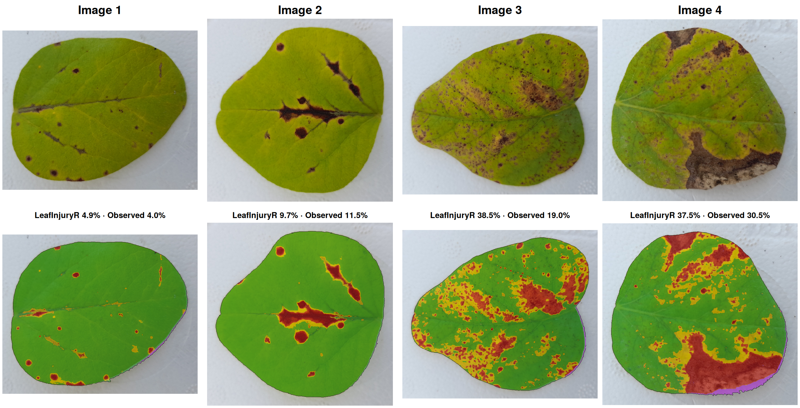
Source: the author (2026).
These results have two practical implications. First, the raw LeafInjuryR measurement should not be interpreted as the numerical equivalent of a visual estimate: the two methods measure slightly different constructs, and the difference lies mainly in how chlorotic tissue is counted. Second, when the aim is to maintain comparability with historical series of visual assessments, a calibration curve fitted to a sample rated by experts allows the automated measurement to be converted to the visual scale with an error comparable to that of a rater while preserving reproducibility. Alternatively, when the aim is to measure the area that is actually symptomatic, the raw measurement with a fixed, recorded threshold avoids dependence on the rater, which, as shown in Figure 5, can change decisions in up to a quarter of cases.
With respect to existing tools (Table 4), LeafInjuryR was not compared experimentally with ImageJ/Fiji, PlantCV or pliman, and no claim of superior accuracy can be made. ImageJ/Fiji offers great flexibility, but severity quantification depends on user-built macros; PlantCV is oriented towards programmed Python workflows for high-throughput phenotyping; pliman provides, within R, severity measurement from colour palettes or image indices, evaluated against reference measurements (Olivoto, Andrade & Del Ponte, 2022); and dedicated programs such as Assess and Leaf Doctor prioritise direct interaction with hue thresholds. The contribution of LeafInjuryR lies in combining, in a single workflow, the explicit separation between segmentation and classification, automatic recording of parameters, corrections and image identity, quality controls that do not alter results, and self-contained reports for auditing, aspects associated with computational reproducibility (Sandve et al., 2013; Wilkinson et al., 2016). The main limitations of the study are the number of leaflets, the restriction to one pathosystem and one acquisition system, the absence of pixel-level reference masks, which prevents determining whether the divergence arises from the software or from the raters, and the fact that one of the raters is an author of the package. The calibration obtained is specific to this set and must be re-estimated under other conditions.
Table 4 – Qualitative methodological comparison among severity-quantification tools, based on documentation and literature
Feature | ImageJ/Fiji | PlantCV | pliman | Assess / Leaf Doctor | LeafInjuryR
Environment | Java; GUI and macros | Python library | R package | Dedicated program and app | R package and local Shiny
Programming required | Optional (macros) | Yes | Yes | No | Optional
Batch processing | Via macro | Yes | Yes | Limited | Yes, with error isolation
Explicit leaf/tissue separation | User-defined | User-defined | Via palettes or indices | Not explicit | Yes, mandatory
Recorded manual correction | Not automatic | No | No | No | Yes
Automatic record of parameters and MD5 | No | Partial | Partial | No | Yes
Built-in validation metrics | Via plugins | Not specific | Not specific | No | IoU, Dice, Se, Sp, Pr, F1
Source: the author (2026), based on Schindelin et al. (2012), Gehan et al. (2017), Olivoto (2022), Lamari (2008) and Pethybridge and Nelson (2015). Qualitative comparison; not a performance evaluation.

4 CONCLUSION
LeafInjuryR quantifies foliar symptoms reproducibly and auditably, separating leaf segmentation from tissue classification and recording every analysis parameter. For soybean target spot, visual assessment with a standard area diagram showed enough variability to change decisions for 12.5% to 25.0% of the leaflets, depending on the threshold adopted.
Severity measured by LeafInjuryR was highly correlated with observed severity but higher than it at elevated severities, a relationship well described by a power model. After calibration, the software predicted observed severity with agreement equivalent to that of experienced raters, and lowering the healthy-tissue hue threshold had a similar effect, pointing to the healthy–chlorotic boundary as the main parameter to calibrate. Validation with pixel-level reference masks and in other pathosystems is the next step to establish its accuracy.

REFERENCES
BArbedo, J. G. A. (2013). Digital image processing techniques for detecting, quantifying and classifying plant diseases. SpringerPlus, 2, 660. https://doi.org/10.1186/2193-1801-2-660
BArbedo, J. G. A. (2014). An automatic method to detect and measure leaf disease symptoms using digital image processing. Plant Disease, 98(12), 1709-1716. https://doi.org/10.1094/PDIS-03-14-0290-RE
BArbedo, J. G. A. (2019). Plant disease identification from individual lesions and spots using deep learning. Biosystems Engineering, 180, 96-107. https://doi.org/10.1016/j.biosystemseng.2019.02.002
BOck, C. H. et al. (2010). Plant disease severity estimated visually, by digital photography and image analysis, and by hyperspectral imaging. Critical Reviews in Plant Sciences, 29(2), 59-107. https://doi.org/10.1080/07352681003617285
BOck, C. H. et al. (2020). From visual estimates to fully automated sensor-based measurements of plant disease severity: status and challenges for improving accuracy. Phytopathology Research, 2, 9. https://doi.org/10.1186/s42483-020-00049-8
BOck, C. H., CHiang, K.-S., DEl Ponte, & E. M. (2022). Plant disease severity estimated visually: a century of research, best practices, and opportunities for improving methods and practices to maximize accuracy. Tropical Plant Pathology, 47(1), 25-42. https://doi.org/10.1007/s40858-021-00439-z
CHang, W. et al. (2024). shiny: web application framework for R. R package. https://CRAN.R-project.org/package=shiny
Commission Internationale de l'Éclairage (2004). Colorimetry (3rd ed.). CIE.
DEl Ponte, E. M. et al. (2017). Standard area diagrams for aiding severity estimation: scientometrics, pathosystems, and methodological trends in the last 25 years. Phytopathology, 107(10), 1161-1174. https://doi.org/10.1094/PHYTO-02-17-0069-FI
GEhan, M. A. et al. (2017). PlantCV v2: image analysis software for high-throughput plant phenotyping. PeerJ, 5, e4088. https://doi.org/10.7717/peerj.4088
HAmuda, E., GLavin, M., JOnes, & E. (2016). A survey of image processing techniques for plant extraction and segmentation in the field. Computers and Electronics in Agriculture, 125, 184-199. https://doi.org/10.1016/j.compag.2016.04.024
HOrsfall, J. G., BArratt, & R. W. (1945). An improved grading system for measuring plant diseases. Phytopathology, 35, 655.
JAmes, W. C. (1971). An illustrated series of assessment keys for plant diseases, their preparation and usage. Canadian Plant Disease Survey, 51(2), 39-65.
LAmari, L. (2008). Assess 2.0: image analysis software for plant disease quantification. APS Press.
LIn, L. I.-K. (1989). A concordance correlation coefficient to evaluate reproducibility. Biometrics, 45(1), 255-268. https://doi.org/10.2307/2532051
LObet, G. (2017). Image analysis in plant sciences: publish then perish. Trends in Plant Science, 22(7), 559-566. https://doi.org/10.1016/j.tplants.2017.05.002
MAdden, L. V., HUghes, G., VAn Den Bosch, & F. (2007). The study of plant disease epidemics. APS Press.
MCgraw, K. O., WOng, & S. P. (1996). Forming inferences about some intraclass correlation coefficients. Psychological Methods, 1(1), 30-46. https://doi.org/10.1037/1082-989X.1.1.30
MEyer, G. E., NEto, & J. C. (2008). Verification of color vegetation indices for automated crop imaging applications. Computers and Electronics in Agriculture, 63(2), 282-293. https://doi.org/10.1016/j.compag.2008.03.009
MOhanty, S. P., HUghes, D. P., SAlathé, & M. (2016). Using deep learning for image-based plant disease detection. Frontiers in Plant Science, 7, 1419. https://doi.org/10.3389/fpls.2016.01419
MUtka, A. M., BArt, & R. S. (2015). Image-based phenotyping of plant disease symptoms. Frontiers in Plant Science, 5, 734. https://doi.org/10.3389/fpls.2014.00734
NUtter Jr., F. W. et al. (1993). Assessing the accuracy, intra-rater repeatability, and inter-rater reliability of disease assessment systems. Phytopathology, 83(8), 806-812. https://doi.org/10.1094/Phyto-83-806
OLivoto, T. (2022). Lights, camera, pliman! An R package for plant image analysis. Methods in Ecology and Evolution, 13(4), 789-798. https://doi.org/10.1111/2041-210X.13803
OLivoto, T., ANdrade, S. M. P., DEl Ponte, & E. M. (2022). Measuring plant disease severity in R: introducing and evaluating the pliman package. Tropical Plant Pathology, 47(1), 95-104. https://doi.org/10.1007/s40858-021-00487-5
OTsu, N. (1979). A threshold selection method from gray-level histograms. IEEE Transactions on Systems, Man, and Cybernetics, 9(1), 62-66. https://doi.org/10.1109/TSMC.1979.4310076
PAu, G. et al. (2010). EBImage: an R package for image processing with applications to cellular phenotypes. Bioinformatics, 26(7), 979-981. https://doi.org/10.1093/bioinformatics/btq046
PEixoto, M. J. (2023). Elaboração e validação de escala diagramática para quantificação de complexos fitossanitários na soja (Glycine max). Undergraduate thesis (Agronomy), Instituto Federal Goiano, Campus Urutaí, Urutaí, Brazil.
PEthybridge, S. J., NElson, & S. C. (2015). Leaf Doctor: a new portable application for quantifying plant disease severity. Plant Disease, 99(10), 1310-1316. https://doi.org/10.1094/PDIS-03-15-0319-RE
R Core Team (2024). R: a language and environment for statistical computing. R Foundation for Statistical Computing. https://www.R-project.org/
ROsenfeld, A., PFaltz, & J. L. (1966). Sequential operations in digital picture processing. Journal of the ACM, 13(4), 471-494. https://doi.org/10.1145/321356.321357
SAndve, G. K. et al. (2013). Ten simple rules for reproducible computational research. PLoS Computational Biology, 9(10), e1003285. https://doi.org/10.1371/journal.pcbi.1003285
SChindelin, J. et al. (2012). Fiji: an open-source platform for biological-image analysis. Nature Methods, 9(7), 676-682. https://doi.org/10.1038/nmeth.2019
SChneider, C. A., RAsband, W. S., ELiceiri, & K. W. (2012). NIH Image to ImageJ: 25 years of image analysis. Nature Methods, 9(7), 671-675. https://doi.org/10.1038/nmeth.2089
SEzgin, M., SAnkur, & B. (2004). Survey over image thresholding techniques and quantitative performance evaluation. Journal of Electronic Imaging, 13(1), 146-165. https://doi.org/10.1117/1.1631315
SIngh, A. K. et al. (2018). Deep learning for plant stress phenotyping: trends and future perspectives. Trends in Plant Science, 23(10), 883-898. https://doi.org/10.1016/j.tplants.2018.07.004
SOille, P. (2003). Morphological image analysis: principles and applications (2nd ed.). Springer. https://doi.org/10.1007/978-3-662-05088-0
WIckham, H. (2016). ggplot2: elegant graphics for data analysis (2nd ed.). Springer. https://doi.org/10.1007/978-3-319-24277-4
WIckham, H., BRyan, & J. (2023). R packages (2nd ed.). O'Reilly.
WIlkinson, M. D. et al. (2016). The FAIR Guiding Principles for scientific data management and stewardship. Scientific Data, 3, 160018. https://doi.org/10.1038/sdata.2016.18
WOebbecke, D. M. et al. (1995). Color indices for weed identification under various soil, residue, and lighting conditions. Transactions of the ASAE, 38(1), 259-269. https://doi.org/10.13031/2013.27838

